LBNC Questions from May 11 Review Meeting
May 28, 2021
Production Readiness
- We understand that the FDR process will review the design readiness for production (including R&D results), and PRR process will include assessment of the quality of preproduction components and assemblies, and the readiness of production factories. Design/engineering reviews (Failure Mode analyses etc) will feed into the FDR process, and initial production grade assembly into the PRR. Both may be a series of reviews, one per subsystem. Is this correct? Please clarify.

Yes, FDRs and PRRs will be held individually for each consortium. FDRs will be done in preparation for the CD-3 process by Spring 2023. PRRs will be necessary prior to committing resources for production and will be completed by fall/winter 2023, profiting from the experience gained in construction of Module-0.

- Please provide more information on the plans leading into production following module-0 experience. These might include small quantity purchases from selected vendors, small quantity production grade assembly and quality verification, certification of quality from production sites. What in these plans precedes the PRR and what follows?
DAQ: After ProtoDUNE-II module-0, in 2024 the DAQ integration and testing activity will shift to FNAL, in a dedicated lab, pre-series samples (~10%) of servers, network devices and readout cards will be used for scalability, performance and stability tests. From 2025 the integration lab will also be used to qualify and configure all purchased devices, prior to shipping material to the warehouse near SURF.

HV: By the time of the module-0 production, we will have identified all sources of components and fabrication/assembly sites. We will purchase some extra material beyond what is needed for module-0. After the installation of the module-0, while waiting for the test results, we will start to refine production tooling, and practice some sample production for training purpose. After the test results are in, we will have a review to determine if any modification of the component is necessary. The production site will then start to produce pre-production articles using the extra material already in hand. These pre-production items will be reviewed at the PRR. Once we pass the PRR, procurement of the production components will start.

Anode: Anode PCB production steps and the quality of the fabricated pieces were demonstrated at small scale in the 50L test stand. The cold-box, which is currently being fabricated, will provide valuable input for the production, quality control and performance measures for the full-scale CRP. Lessons learned from the first cold-box test will be incorporated into the production of Module-0 components. By the time of module-0 production, we’ll have identified vendors, well defined acceptance tests and QC procedures. Those will be re-verified by Module-0 runs and the production for the far detector will follow.

CRP: The quality aspects and the verification on the elements for the composite frame structure, the anode attachment spacers, the decoupling systems of the top structure will be performed on the quantities needed to build the module-0 CRPs before the PRR. In this process the vendors will be already identified with a clear quality assessment requirement When production of the final structures and components will start, quality controls will be performed at the production sites before delivery to the CRP assembly factories. For the bottom CRP supporting system, a dedicated pre-production and prototyping effort should be done in parallel to the Module-0 test. This will give the needed quality certification before starting the full production.

PDS: Module-0 (ProtoDUNE-II testing) of the PDS represents our primary QA test for all vendors and component designs. All final detector components will be tested in a representative environment, and vendor performance will be certified with our QC test plans. The PRR will follow ProtoDUNE-II and will be principally informed by the results of that experience. No additional design validation or vendor performance certification is planned to follow the PRR prior to ordering production components.

Production contracts for certain key components perceived to be particularly sensitive to production lot variation will be written to include first article inspection from production lot fabrication where possible. This will be included in our QC plan and documented as part of the PRR. Examples of this might include SiPMs, optical filter plates, wavelength-shifting plates, and print circuit board fabrication/assembly.

Electronics top: For what concerns the top drift electronics there is the production experience from NP02 which concerns an equivalent quantity as the one foreseen for module-zero and this electronics is still valid for module zero with minor modifications. However, in view of developing the production organization for the VD and the costs we already started testing new vendors in order to evaluate the production quality and develop the production costs optimization. For instance for what concerns the cryogenic front-end cards for the cold-box tests, which needed to remove some biasing components used for the dual-phase anodes, instead of modifying existing cards it was taken the occasion to produce these cards from scratch to test a new vendor. The cards are also mounting a new batch of cryogenic ASIC chips produced in 2020. The new cards haven been already delivered and tested. This experience has been very satisfactory and supportive of the path for massive production. This process, which essentially corresponds to what mentioned in the question, is foreseen to be repeated in small quantities for all components in view of the module zero in order to support the cost optimizations and the diversification and validation of the vendors. After module-zero the costs optimization and validation of vendors is supposed to be completed in support of the PRR and all potentially interested vendors will be verified. Then the main production process will also imply the production of first acceptance batches and a continuous follow-up procedure of the next batches. Similarly, for what concerns the QC procedures in different sites it is foreseen that before production the basic set-up for QC test will be cloned to other sites participating to the QC effort and validate their qualification.

Electronics bottom: The bottom readout electronics is the same as FD1-HD with some potentially minor differences in the cabling scheme. By the time FD2-VD is ready for PRR, the components are already in the production stage for FD1-HD. The experience and lessons learned from FD1-HD production run will be incorporated into the production plan for FD2-VD.
- There are a very large number of interconnections in the CRP assembly, both vertical and lateral. Connection reliability is often the bane of efficient assembly, particularly if disconnect and reconnect is needed for repair. Please describe the plans to ensure the ease and reliability of the connections.
The lateral connection of the anode strips across board segment boundaries is analogous to the wire soldering at the edges of the wire wrap boards on the APAs. On average, an APA induction wire wraps around an edge twice, each time has 2 solder joints for a total of 4 solder joints. In comparison, the current perforated anode design limits the induction strip widths within half a CRU length. On the prototyping stage, these half CRUs are made from 3 PCB segments, with two joints along most of the induction strips. Some of the diagonal strips have 3 joints. But overall, the number of joints along the induction strips on the CRPs are much less than that of the APAs. At the production time, the CRU will be made from two PCB segments, so only one join is needed on all induction plan signals. The electrical interconnect is made by screen printing of conductive ink pad, a standard PCB fabrication technique. Since the mechanical bond of the PCB segments is rigid, no movement across the PCB segment gaps is expected. Test samples of the conductive ink across PCB boundaries have been repeatedly thermal shocked without any ill effect. The 1st cold-box test of these anode will be the first large scale test of these joints, and failure of these interconnects are easily observed by the readout electronics. A backup/repair solution is to simply place a solder bead across the strip ends at the joint. This is still less labor intensive than that of the APAs.
The vertical interconnect also compares favorably to that of the APAs. Instead of adding a “CR” board between the signal wires and the FEE, the bias RC components are directly integrated onto the readout adapter boards. So, there is one less pin-socket connection in the CRP readout chain than that of the APAs. To improve the reliability of the connections, the diagonal strips in the current CRPs have redundant pins to bring the signal to the adapter board. This feature will be evaluated in the prototyping stages to balance the redundancy and ease of plugging in the large boards.
As was presented in the review, edge card connectors will be evaluated in the next round of small-scale tests. These connectors eliminate the need to solder pins/sockets on the large boards and are less sensitive to the board alignment for electrical connection. If adopted, they will greatly reduce the time it takes to connect the anode to the readout adapter boards from a few days to a few hours.
The pins and sockets connection is the tried-and-true solution used in MicroBooNE and ProtoDUNE. The edge connection method is new for LArTPCs. It has great promise and technical challenges. We are working closely with the CERN PCB workshop to develop and adapt each solution for the large PCBs in the CRPs.
- What are the plans for longevity and stress testing of subassemblies, mitigating the risk of early-life failures?
CRP: Longevity and stress tests for the CRP sub-assemblies have been started at the component level. Every new material, production procedure, small-scale component or prototype is submerged into the LAr as the first test to verify its cryogenic compatibility.

Concerning perforated anode PCBs, so far gluing and conductive ink treatment, two of the key assembly steps to produce large planes, have been prototyped and tested. Gluing procedure, cryogenic compatibility of the used epoxy and the conductive ink have been tested in LAr. Several cryogenic cycles, abusive mechanical pressure tests on the glued zone, electrical continuity and resistance measurements did not reveal any sign of failure. Gluing and conductive epoxy treatment of full-scale anodes will be tested in 2021/2022 during the cold-box anode assembly and later during the integrated system runs. The first cold-box anode, with 3 times as many of glued edges, will provide especially valuable input for the longevity and stress tests.

Performance of the perforated anode PCBs have been tested and will continued to be tested at the 50L test stand. Several cryogenic cycles with 2-view prototype and 3-view prototype did not show any sign of performance degradation. All readout strips and electrical components are functioning as expected. The electrical components of the adapter boards, which are also used on the CR boards of the APAs, will be tested in various cold-box runs and full-scale prototypes in the next few years.

Current design for the vertical interconnection between the PCB layers and adapter boards uses standard board stacking connectors. This connection method is currently being tested at the 50L test stand and will be tested at full scale in the first cold-box in 2021. An alternative method of the vertical interconnections is the edge connectors. Spring loaded connectors, custom locking mechanism, any special treatment required on the strips will be tested at a dedicated test stand for their long-term functionality and performance.

All mechanical parts (composite frame, spacers and decoupling devices) used in a full-size CRP will undergo mechanical stress test during the process of prototyping in the cold-box during the coming 2 years. Several cold cycles will be performed independently to study monitor the general geometry and integrity of a full CRP over time, especially at the level of the anode support system and mechanical links. In parallel small prototypes mimicking a CRP structure made of PCB assembly on a small support frame with spacers will be prepared to undergo exaggerated mechanical effort test to confirm and validate the mechanical behavior. In addition, all materials chosen for the various mechanical parts will be carefully controlled and validated for compatibility with liquid argon using the Material Test Stand facility at Fermilab by 2022.

PDS: For FD2 PDS, we plan to conduct component-wise longevity and stress testing in 2022, and system-level medium-term longevity and stress testing at ProtoDUNE-II in 2023. The breakdown of testing approaches is by mechanical and electrical components.

For mechanical components, the stress testing strategy is repeated thermal cycle testing based on the model that this best simulates long-term aging effects within a manageable timeframe. We will leverage the experience from the FD1 PDS mechanical longevity and stress testing approaches (e.g. targeting 20 thermal cycles to conservatively represent DUNE operations lifetime) and will utilize experience from FD1 PDS shared components (SiPMs, filter plated, WLS bars, frame components) wherever possible. In the case of components or techniques unique to the FD1 PDS (primarily the attachment of SiPMs to the WLS bars and Kapton (R) flexible PCBs), dedicated cryogenic testing will be conducted to validate performance, including component level multi-cycle stress tasting and system testing of module prototypes.

For electrical components, the literature points to hot-carrier effects (in transistors where electrons are the majority carriers) as the primary aging mechanism and that elevated voltage supply stress testing accelerates the process. There is an understood relationship between voltage supply scaling and cold lifetime estimates that we will use to qualify components for 30-year lifetime while monitoring critical operating parameters. We also plan to leverage existing component lifetime studies (BNL, ProtoDUNE, JPL, FD1 PDS, etc.) wherever possible to avoid qualifying each component ourselves.

Integrated system testing will occur at several stages in the FD1 PDS development. Mechanical testing of mechanical prototypes, including SiPM mounting to WLS bars and full frame assemblies, will occur at CSU in Q3 2021. Cold-box testing of fully integrated modules in a cathode plane will occur in late 2021/early 2022. ProtoDUNE-II gives us the opportunity to demonstrate a full integrated system test. We will deploy a 1/20th scale module-0 test for a period of 6−12 months which, upon successful completion, will give us confidence the system will operate longer term.

Aside from longevity qualification, stress-test survival, and longer term 1/20th scale system testing, to give us the best chance of 30-year survival, we plan to build redundancy into the design, wherever we can afford. This gives us headroom for missing a system level single-point of failure at 3−10-year timelines. If there are opportunities for 5x−30x level redundancy (e.g., multiplexed control or readout paths), then surviving 30-years starts to become granted for those components.
CRP Production
5. Are there special challenges to consider with the production of the anode PCBs, or are the specs within common industry standards? Is there a plan to work with vendors to develop larger PCBs requiring fewer inter-board connections?
Production steps and techniques used for manufacturing the perforated PCBs are within common industrial standards. The main production steps like cutting, drilling, copper plating, layout, pattern plating, etching are no different than those used for standard 2-layer PCB production.

What is not common for the industry is the size of the panels and large number of holes that need to be drilled. Currently, we are working together with the CERN PCB workshop, which has years of experience to build all kinds of PCBs and has close contact with industrial partners. Our approach with acquiring large perforated PCBs is to minimize the cost by using the commercially available tools and techniques. Initial communications with vendors have revealed the possibility to produce 1.5m×1.7m PCB panels and drilling them with available machines. These 1.5m×1.7m panels will reduce the number of inter-board connections to one per CRU and simplify the assembly procedure.

We’ll continue to work closely with the CERN PCB workshop and vendors to investigate any additional possibility to produce larger perforated PCBs.
6. Slide 14 shows the institutions involved in the CRP work. It seems to imply a major role for the CERN group, in monitoring gluing processes and procurements, QC etc. How do you foresee the partnership CERN- BNL in this work?
One of the main advantages of the vertical drift is to have detector component that can be commercially manufactured. The anode planes with commercially produced and drilled PCBs are good examples for this feature. The CERN group, with various important responsibilities in the CRP work, is using this “commercially produced” feature extensively. Responsibilities like gluing, procurement, production will be executed by the specialized constructors/companies working inside CERN. In addition, being an international laboratory with visiting students and researchers, QC activities is planned to be performed with the contribution of colleagues from different institutions.

Having said that, the CERN and BNL groups have been working closely since the beginning of the vertical drift concept. Anode design, R&D, building and testing small scale prototypes and cold-box preparations are some of the main partnership activities ongoing currently.

Collaboration between the two institutions will continue in the near future for the far detector activities as well. As indicated in the project planning documentations (WBS, P6,) for the far detector, various activities related to the anodes production and their cost is shared half and half between the institutions.

7. Please clarify the work/responsibility boundary between the PCB-Anode work at CERN and the CRP assembly at the four factory sites.
CERN together with the PCB workshop/industrial partners and BNL is going to be responsible to provide anode components that CRP factories will use to assemble CRPs. These components will include perforated anodes, adapter boards and interconnection boards. The QC of the glued perforated PCBs, adapter and interconnection boards will be part of this responsibility. Then the CRP factories will assemble perforated PCBs together with the CRP mechanical support. QA/QC for the assembled CRPs and its shipping to the South Dakota will be the responsibility of the CRP factories as well.

Besides contributing to anode component supply, if needed, CERN neutrino platform with the available clean rooms and infrastructure can provide working space and expert help to support one of the possible CRP production factories in Europe.
PDS Production
8. Please compare the number of components for VD to the HD PDS and outline the model for production, including the role of vendors and participating institutions. Please discuss the relationship between this production and the production of the HD system (which might be different for the Arapucas on the membrane and those on the cathode).
PDS: FD2 PDS strategy is to overlap where possible with FD1 PDS on vendor selection (in particular for photosensors, dichroic filter plates and wavelength shifting (WLS) plates); we do not foresee FD1 + FD2 quantities presenting a burden to any vendors.
FD2 PDS strategy for identifying participating institutions is to utilize existing groups from the FD1 PDS where appropriate (such as module design, filter plates, WLS plates, and SiPMs) and for new development efforts such as power over fiber and cold electronics to focus on institutions not yet involved in FD1 activities to minimize any impact of the VD1 PD production. It is important to note that additional resources have already been identified and are already actively involved in these new R&D efforts.

The tables below provide a comparison between the FD2 PDS reference design, backup configuration, and FD1 PDS reference design.

Table 8.1: FD2 PDS Vertical Drift 4π Reference Configuration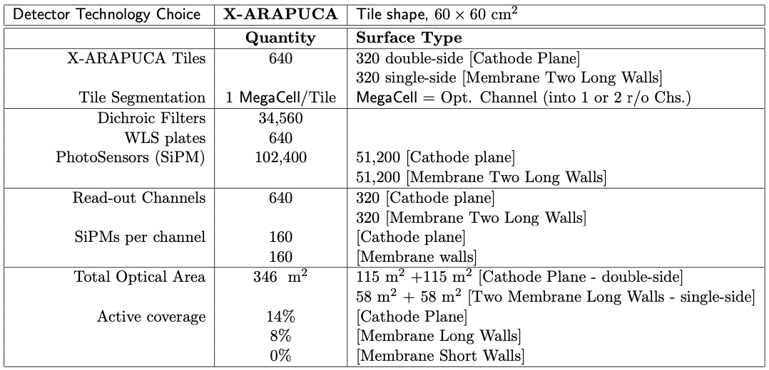
Table 8.2: FD2 PDS Vertical Drift Backup Configuration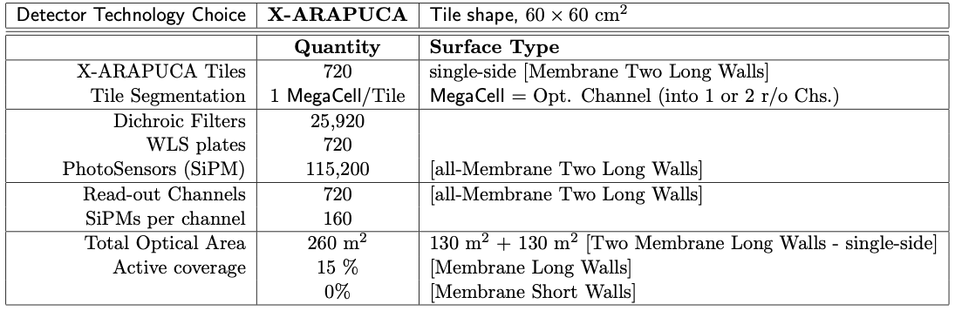

Table 8.3: FD1 PDS Horizontal Drift Reference Design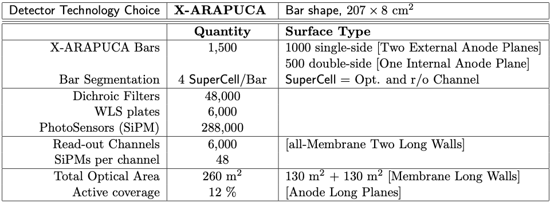

Installation
9. We’ve seen in Marzio Nessi’s talk that, for much of the installation period, the Ross Shaft will be operating almost at its capacity limit. Does this incur a risk of “traffic jams” that will delay installation? Especially in case one of the detectors experiences a delay?
The Ross shaft will be operating in some occasion up to 85%. There is still the possibility to smooth this curve and anticipate some of the movements of material profiting for the large cavern surface area for storage, such to arrive to a maximum occupancy around 70%. The Ross Shaft has sufficient capacity to move personnel and materials needed for two detectors underground on the timeline required. Personnel movement still represents more than 40% of the shaft usage, but this is limited to the hours connected to the start and finishing of the shifts. Most of the material is foreseen to be lowered during the day shift and less during the evening shift.

In case of delays we can still organize that the Yates shaft is also used to move personnel, liberating some capacity of the Ross shaft. The evening shifts can absorb some of the additional load and we can use the Saturdays to bring down more material.

In case of delays the most critical period will be during the construction of the second warm cryostat which will be in competition with the installation of the first cold cryostat. Once this period is over then the size of the material to be lowered will be less important and various solutions can be envisaged to speed up the movement of material.

10. How reliant is the installation plan on “just in time” delivery?
Just on time delivery must be avoided as much as possible. TCn will have to follow up and monitor the progress of each consortium during mass production and anticipate possible problems and delays. The DUNE EB will have to be strongly involved in this process and take an active role. As it was presented in the review, the various consortia have still some margin of operation and the production period from mid 2023 to, in most cases, end of 2026, for a total of more than 3 years of production, is judged to be realistic.

The 3 months ready for installation milestones must be respected at any cost and derogations will have to be well understood and planned. The installation schedule of 9 months has a contingency of 1.5 months and some of the work can still happen in parallel inside the cryostat in case of delays of arrival of some material.

Schedule
11. Where is there contingency in the schedule, and what are the opportunities to mitigate schedule delays?
See question 10. Yes, there is still some contingency on the schedule both for the mass production and for the installation.

To mitigate schedule delays, we have first to make sure at the PRRs that all material contracts have been understood and negotiated. The assembly factories for CRPs and Arapucas will need to be ready and qualified. The transport and logistic plans and contracts must be well understood.

TCn and the DUNE EB will have to have a very active role in monitoring the progress of the readiness and of the production on a monthly basis, avoiding surprises and must be ready to make adjustments and take decisions on non-conformity issues which might affect the entire detector.

FDRs and PRRs must be done in a very rigorous way, without hiding or ignoring possible problems. MOUs will have to be signed and will have to detail the individual partners responsibilities. An open channel of communication between the DUNE management and the various funding agencies must be well consolidated.

All possible delays or problems must be made visible to the management of the LBNF/DUNE project with enough anticipation to allow eventual reorganization of the installation activities.

12. The presentations indicated a throughput of 1 CRP per week for each of four factory sites. This is presumably a steady-state flattop rate [?].
a. The schedule should include a ramp-up period including training and quality validation, developing from pre-production factory certification through a period where production issues are ironed out. Please discuss.
Yes, there will be a ramp-up period; the production schedule was not showing this period foreseen for testing the CRP factory and the production of few CRPs to certify it. There is a possible ramp-up time of about 4 months starting from end of 2024 before going to the steady-state flattop rate of 1 CRP per week.
b. Delivery of component or temporary quality issues may require periods of burst-mode above the 1 CRP per week average. What will be the maximum capability be?
The capability to increase the rate may exist already in the present estimate. The maximum in one factory can be 2 CRP/week when running in 2 shifts
c. What are the present assumptions per assembly site in terms of shifts per day and days per week? If there are delays in the R&D phase or module-0 validation, what are the options to speed up production (for example adding a second shift or additional assembly site)?
Each CRP factory is foreseen to run in 1 shift/day mode, 5 days/week. A second shift could be added for critical periods to resorb delays if any.
The CRP production schedule is such that there a contingency of 3 months available if the production got delays due to availability of components or quality issues.
13. Please describe the equivalent model for the PDS production.
PDS: For FD2 PDS we are working to identify production sites at collaborating institutions. The minimum plan is for two production sites, possibly more depending on interest from collaborators and understood requirements to meet production requirements. We plan to launch production orders over three years beginning in 2024 and for construction to ramp up during summer of 2024. The baseline plan is for 640 detector tiles for the FD2 PDS. In the baseline schedule, the 640 detector-tile construction should be completed by the end of 2026.

If we conservatively ignore the ramp-up period in 2024, then the target production rate to make 640 tiles in 2025-26 (assuming 40 working weeks per year) is 8 tiles per week. Split over two sites, this implies the assembly line has no bottlenecks preventing completion of 1 tile per day.
Costed labor per tile, we have in WBS the following:
- 3 hours/tile Fermilab Electrical Technician
- 3 hours/tile Fermilab Electrical Engineer
- 3 hours/tile Fermilab Mechanical Technician
- 3 hours/tile Fermilab Mechanical Engineer
- 3 hours/tile Fermilab Software Engineer
- 20 hours/tile Generic Univ Student
- 9 hours/tile Generic Univ Electrical Technician
- 9 hours/tile Generic Univ Mechanical Technician
14. What are the drivers for the CRP and PDS schedules? Why does the CRP assembly start June/Oct 2025 (Component Production slide 11)?
CRP: the driver for the production schedule is based on the nominal rate of 1 CRP/week and on the need to deliver the CRPs to South Dakota 3 months in advance of installation

PDS: The PDS production phase will be launched after a successful Production Readiness Review (PRR). We anticipate the PRR to be completed at the start of 2024. We are being encouraged to break our production orders into three phases to spread out costs over 3 years. The schedule drivers for PDS once the production phase begins are procurement handling, vendor lead-time, and production site throughput rate. We have no schedule logic interfaces to other subsystems until installation begins.

Many of the same detector components will drive the PDS production as the FD1 PDS: photosensors, dichroic filter plates and WLS plates. Fortunately, the baseline design calls for using similar or identical components for FD2 PDS, which should mitigate production delay concerns. As for FD1 PDS, schedule risk is significantly mitigated by a two-vendor strategy for both photosensor and WLS plate fabrication. The third critical component (dichroic filters) benefits from a very close working relationship between the vendor (OPTO Inc.) and UNICAMP. This will allow for close monitoring of the production to mitigate risks from production delays.

